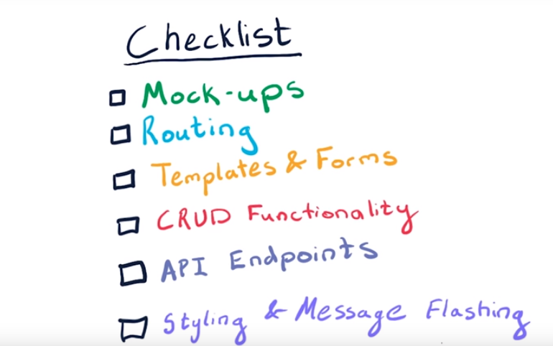

**STEPS FOR EACH ITERATION**

**Iteration 1:**

design page navigation, mockups and urls for the pages

**Iteration 2:**

create the flask routing functions, returning dummy text

**Iteration 3:**

Make fake database elements (dummy data) as python dictionaries and lists(because we haven’t yet connected to a database)

Create a template for each page.

Replace dummy text return statements with render_template(…) for each page

In links and form action fields use ‘#’ as a link (do not link the pages yet)

You should return different statements in pages if there are no elements. For example, on the menu page, return a message that there are no menu items yet, in case the menu items list is empty

**Iteration 4**

Add CRUD functionality

Add url_for and redirect where needed

Add get and post to routes

**Iteration 5**

Create JSON endpoints

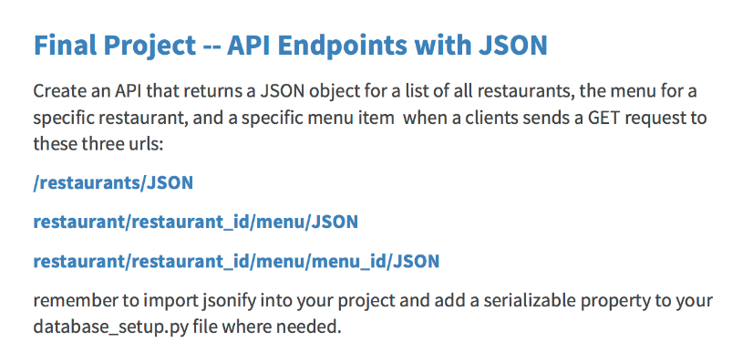

**Iteration 6**

Make a static folder and add CSS, javascript and images. Also add the following flash messages

